Unit 4 I have big eyes 同步练习
一、连词成句
1. legs two I have .
___________________________________________________
2. nose a big I have .
___________________________________________________
二、写出下列单词的中文意思
1. face ____________
2. nose ____________
3. mouth ____________
4. ear ____________
5. eye ____________
三、根据图片写单词
1. 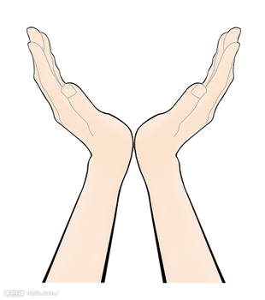__________

2. 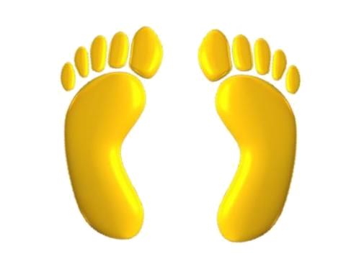__________
3. __________

答案：
一、I have two legs.
I have a big nose.
二、脸； 鼻子；耳朵；嘴；眼睛
三、hand; foot; mouth

